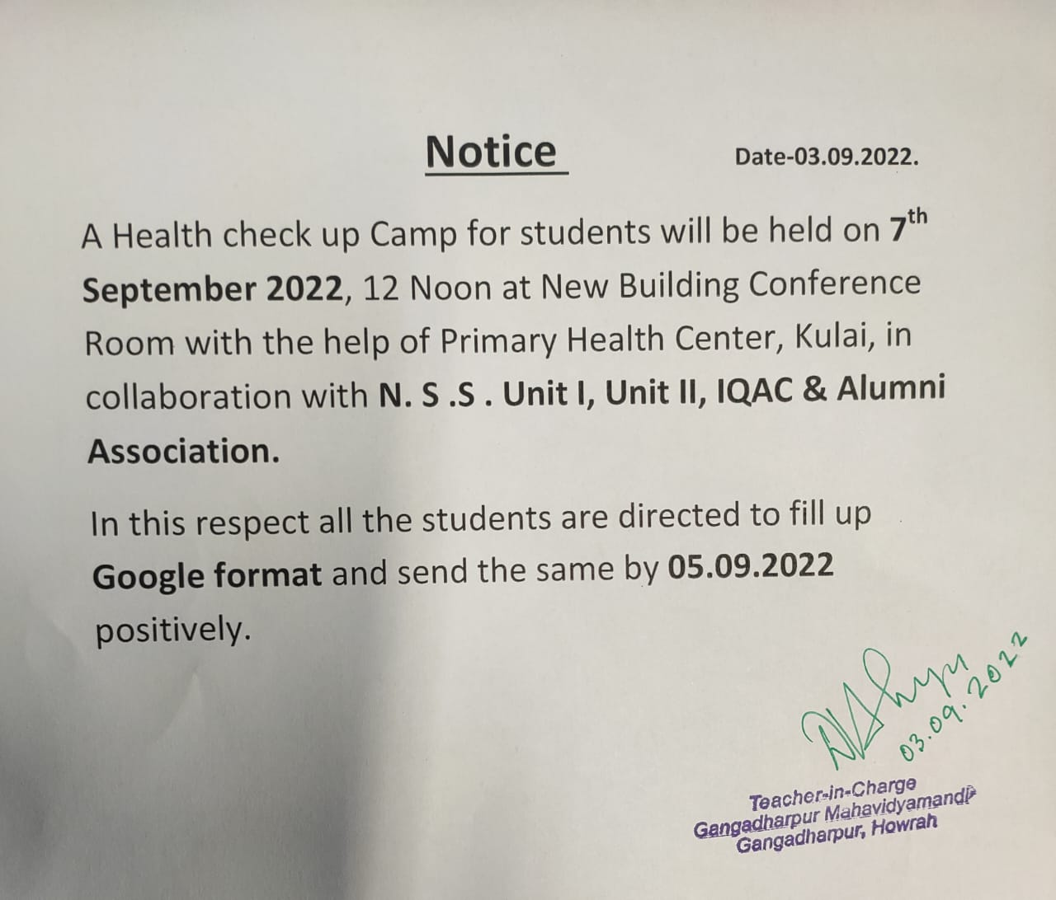
Click the link bellow
https://docs.google.com/forms/d/e/1FAIpQLSe8u1Oz8ZJ5q_ykuwaXoGRj3pcpNoCUx4TlpDmGvIe3vOGRSA/viewform?vc=0&c=0&w=1&flr=0&gxid=-8203364

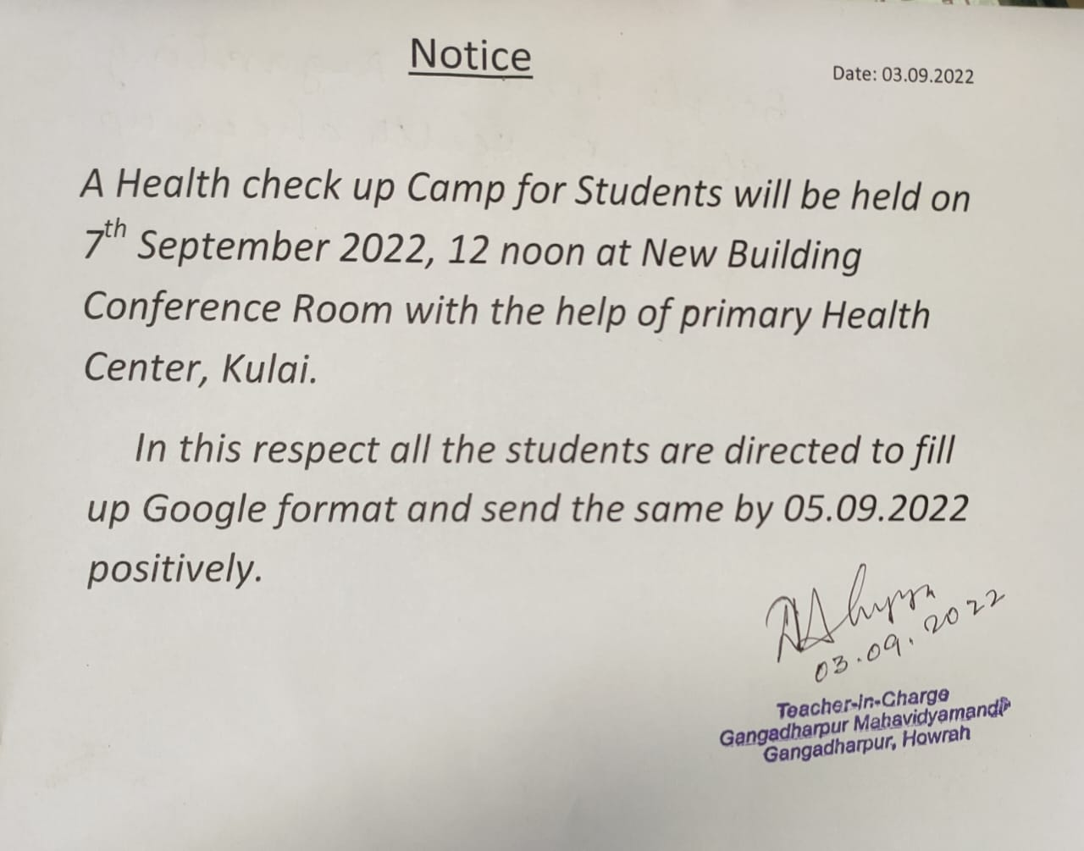

https://docs.google.com/forms/d/e/1FAIpQLSe8u1Oz8ZJ5q_ykuwaXoGRj3pcpNoCUx4TlpDmGvIe3vOGRSA/viewform?vc=0&c=0&w=1&flr=0&gxid=-8203364

